

**Mission 13:**

**Remix**

**Student Workbook**





**You have things under control!**

This assignment will let you be creative and come up with your own program for the   
CodeX to run.



Go to the Mission 13 Remix Log and fill out the Pre-Remix preparation.





**Time for a project remix**

A remix can be:

* A new program created by adding new code to a program you already created
* You can combine parts of two or more programs in a remix
* Use a similar idea in a different way

**Creating a remix will let you:**

* Master the skills and concepts practiced in the mission
* Be creative
* Remember code from earlier programs and missions
* Work with your peers
* Design an original program and write the code all on your own

**Step #1: Review the mission**

* Review your program from Mission 13
  + What does the program do?
  + What skills were used or concepts learned?

**DO THIS:**

* Open your project from Mission 13-   
   Race Control
* Review what the program does
* Review the programming concepts and   
   skills you learned
* Fill out the information in the remix log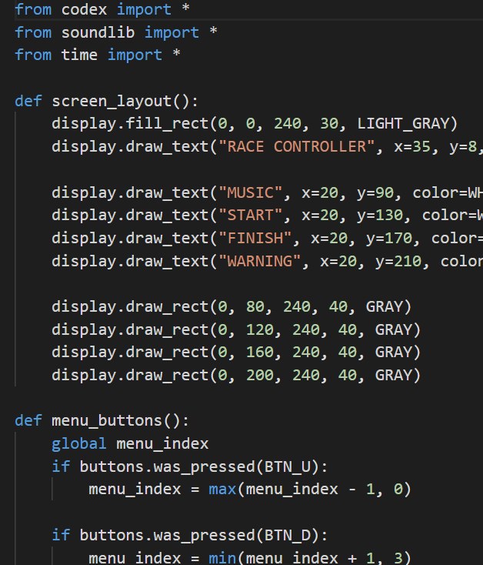

**Step #2: Brainstorm ideas**

* Read through remix suggestions.
  + Six ideas are on the next pages. You can use any of these ideas or come up with your own.
  + You can combine any parts of the suggestions into your own mild, medium, or spicy remix.
* Use your creativity to come up with your own idea for a project.
* Decide with your partner what project you will do.

**Mild Remix #1A**

Use a program from an earlier mission. Add non-blocking music and sounds to the program. 

**Mild Remix #1B**

Use a program from an earlier mission. Add an introduction and/or ending message, and include a border.



**Medium Remix #2A**

Create your own musical instruments. Use a GUI to represent different instruments or controls. Use the buttons to play music. Add sound effects to enhance the musical experience.



**Medium Remix #2B**

Use a program from an earlier mission. Add a toggle for a two-player experience. For example, two different people could have their own personal billboard. Or make the “Reaction Tester” into a 2-player game. 

**Spicy Remix #3A**

Revisit the “dice roller” remix program. Instead of numbers or images, use circles to draw pips for each die number.

**Spicy Remix #3B**

Use a program from an earlier mission. Create a graphical user interface for the program.



**Step #2: Brainstorm ideas**

**DO THIS:**

* Decide with your partner what project   
  you will do
* Fill out the information in the Mission 13  
  Remix Log for **Step #2**

**Step #3: Make a plan**

Now that you have an idea for your remix, you need a plan.

* What variables or constants will you need? What values will they hold, or what will you use them for?
* What graphics and/or sounds will you use?
* What functions will you create and use?
* What buttons will you program, and what will each button do?

**DO THIS:**

* Fill out the information in the Mission 13 Remix Log for **Step #3**

**Step #4: Code your project**

* **IMPORTANT:** In CodeSpace, go to the sandbox: 
* You can leave any program open, including **Race_Control**, and use it as a guide



**DO THIS:**

* Start with a new file and give it a descriptive   
   name (**Remix13**)
* Import your modules
* Create variables and constants as you go or when you see a need
* Use functions to organize your program
* Write your code, testing frequently

**Reminders!**

* Don’t try to write all the code at one time
* Think about the steps –
  + Just get one thing to work, and then move on
  + Step by step!
* Mistakes happen, so find them early
* Type just a few lines of code and then run the program
* If there is an error, fix it before continuing
* Use the debugger and your other programs for help

**Step #5: Documentation**

You should always make your code readable and easy to follow.

**DO THIS:**

* + - * Add blank lines where needed to divide sections of code
      * Add a comment at the top with your name and the name of the program
      * Add a few more comments to sections of your code that explain what they do

**Step #5: Get feedback**

Getting feedback and reflecting on your code can help you make the program even better.

**DO THIS:**

* Show your code to another student
* Have him/her fill out the feedback form on your   
  Mission 13 Remix Log
* Get feedback from someone else (or yourself)
* Have him/her fill out the feedback form on your   
  Mission 13 Remix Log

**Modify your code to make your project even better**

**Congratulations!**

Now you have your own remix!   
Great job! Share your project with   
your friends.

By completing this remix you have:

* learned more about programming
* used skills and concepts from the missions
* been thinking!
* and problem solving
* and much more!

**DO THIS:**

* Run projects from other students
* Complete the Mission 13 Remix Log
* Don’t forget to clear your CodeX by   
  running your **Clear** program